Mozzarella Cheese Sticks $6.00 Emil’s Pizza
Poppers $6.00 Cheese $11.00
Battered Onion Rings $6.00 Sausage $11.00
Crispy Cheddar Nuggets $6.00 Peperoni $11.00
Old-Fashioned Batter-Dipped Mushrooms $6.00 Deluxe $13.00
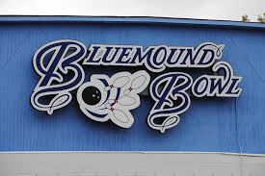
Chicken Tenders $6.00 Garlic Cheese Bread $2.50
Hot Spicy Wings $6.00
Mini Tacos $6.00
Sour Cream and Chive Fries $4.00
French Fries $4.00
All apps come with choice of 1 (one) dipping sauce. Any extra is $0.50
Available sauces:
-Ranch-BBQ-Ketchup-Marinara-Salsa-Hot Sauce-

